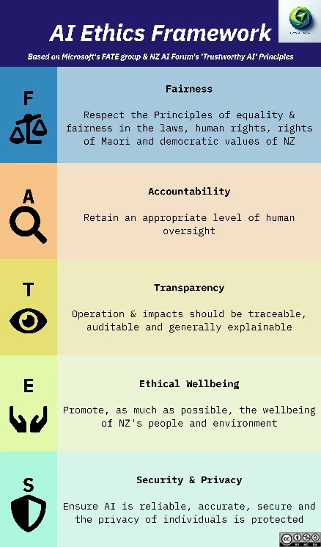
LinkedIn Posts – FATES - Accountability
✨ “That’s not fair!” – A Mini-Series on Ethics in AI - Accountability✨
“It’s what the machine is telling me” – it sounds trite but how often have you actually been told – “the system says……” ?
… you haven’t made a reservation
… that you still owe $67
… that you don’t exist
Existential crises aside, we humans still need to know that there is a PERSON accountable for the decision the system made, in the end. Just for our sanity!
In this mini-series, I’ll share practical ways to implement the FATES Framework in AI projects. While not claiming all the answers, these tips will help you navigate ethics in AI with confidence.
🧑‍⚖️ Today – A for Accountability
I often confuse accountability and transparency when talking through the FATES acronym. It’s easy to conflate them, but it’s an important distinction.
We can be completely Transparent how an AI got to a solution (more on T next week!) yet have no accountability. Accountability means someone is responsible for the decisions made by AI systems. Even if we know how an AI reached its conclusion (transparency), we must ensure humans can question and contest those decisions.
Remember the documentary “Mr Bates vs the Post Office”? (if you work in IT and haven’t watched this – it’s essential!) It’s a cautionary tale of what happens when we give machines the illusion of infallibility—"the system said it, so it must be right." Spoiler: it wasn’t.
Practical steps to improve accountability:
💡Human-in-the-loop – ALWAYS have a ‘right to contest’ as part of the process (GDPR requires this)
💡Questioning space – create a space where people can ask, question, raise concerns …and listen!
💡Alternatives for inequity – measures to ensure that the people who (have to?) use your system have an alternative
💡Frontline flexibility – Empower frontline staff to overrule/adapt based on circumstances
💡Responsibility - Appoint someone who is responsible for the decisions made and the way the system works
💡Audit – Conduct internal and external reviews (e.g., @matrix consulting AI Audits).
The bottom line? NEVER let the system be the final word. Human override isn’t just a safety net - it’s a necessity. After all, no one wants to accidentally build Skynet!
What do you think? Are these steps part of your process, or do they raise new questions for you? Let’s discuss! 👇
#EthicalAI #AIForBusiness #AITraining #FATESFramework

Privacy audits - https://citrusconsulting.co.nz/workshops-audits/
Cyber security risk assessment - https://amaru.co.nz/services/cyber-security-risk-assessments-audits/
Accurate, secure,complint - https://www.matrixconsulting.ai/services/ai-data-audit

